USSD Service Protocol

Table of Contents
1 Interface Modes of the USSDC and USSD Service Application 6
2 Data Types and Message Structure of the USSD Service Application Protocol 6
2.1 Data Types of the USSD Service Application Protocol 6
2.2 Message Structures of the USSD Service Application Protocol 7
3 Message Definitions in the USSD Service Application Protocol 7
3.1 UssdBind 7
3.1.1 Syntax of UssdBind 8
3.1.2 Syntax of UssdBindResp 8
3.2 UssdUnBind 9
3.2.1 Syntax of UssdUnBind 9
3.2.2 Syntax of UssdUnBindResp 9
3.3 UssdShake 10
3.3.1 Syntax of UssdShake 10
3.3.2 Syntax of UssdShakeResp 10
3.4 UssdBegin 10
3.4.1 Syntax of UssdBegin 11
3.5 UssdContinue 11
3.5.1 Syntax of UssdContinue 11
3.6 UssdEnd 12
3.6.1 Syntax of UssdEnd 12
3.7 UssdAbort 12
3.7.1 Syntax of UssdAbort 12
3.8 UssdSwitch 13
3.8.1 Syntax of UssdSwitch 13
3.9 UssdChargeInd 13
3.9.1 Syntax of UssdChargeInd 14
3.10 UssdChargeIndResp 14
3.10.1 Syntax of UssdChargeIndResp 14
4 Description of the Parameters of the USSD Service Application Protocol Messages 15
4.1 Message Header Parameters 15
4.1.1 CommandLength 15
4.1.2 CommandID 15
4.1.3 CommandStatus 15
4.1.4 SenderCB 16
4.1.5 ReceiverCB 16
4.2 Message body parameters 16
4.2.1 AccountName 16
4.2.2 Password 16
4.2.3 SystemType 16
4.2.4 InterfaceVersion 16
4.2.5 UssdVersion 16
4.2.6 UssdOpType 17
4.2.7 MsIsdn 17
4.2.8 ServiceCode 17
4.2.9 CodeScheme 18
4.2.10 UssdString 18
4.2.11 SwitchMode 18
4.2.12 ChargeRatio 19
4.2.13 ChargeType 19
4.2.14 ChargeSource 19
4.2.15 ChargeLocation 19
5 Networking Solutions for the USSD System A USSD Session Instance Initiated by a Mobile Station 20
5.1 A USSD Session Instance Initiated by a Mobile Station 20
5.2 A USSD Session Instance Initiated by the Service Party 21

List of Figures
Figure 1 Interface Model Between USSDC and USSD Service Application 6
Figure 2 A USSD Session Initiated by a Mobile Station 20
Figure 3 A USSD Session Initiated by the Service Party 21

List of Tables
Table 1 Message Structure of the USSD Service Application Protocol 7
Table 2 Syntax of UssdBind 8
Table 3 Syntax of UssdBindResp 8
Table 4 Syntax of UssdUnBind 9
Table 5 Syntax of UssdUnBindResp 9
Table 6 Syntax of UssdShake 10
Table 7 Syntax of UssdShakeResp 10
Table 8 Syntax of UssdBegin 11
Table 9 Syntax of UssdContinue 11
Table 10 Syntax of UssdEnd 12
Table 11 Syntax of UssdAbort 12
Table 12 Syntax of UssdSwitch 13
Table 13 Syntax of UssdChargeInd 14
Table 14 Syntax of UssdChargeIndResp 14
Table 15 Types of the USSD Service Application Protocol Messages 15
Table 16 USSD session version 17
Table 17 Operation types of a USSD session 17

Interface Model of the USSDC and USSD Service Application
The following figure shows the interface model between the Unstructured Supplementary Service Data Center (USSDC) and Unstructured Supplementary Service Data (USSD) service application. The service application interface of the USSDC enables interactions with external USSD service applications through the USSD service application protocol.
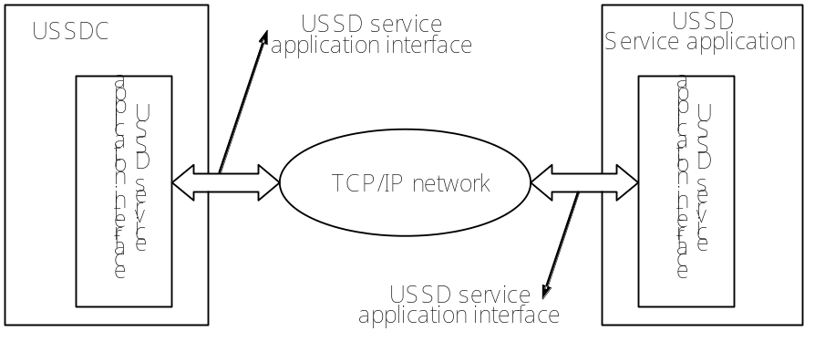
Figure 1 Interface Model Between USSDC and USSD Service Application

Data Types and Message Structure of the USSD Service Application Protocol

Data Types of the USSD Service Application Protocol
The data types of the parameters in the USSD service application protocol are as follows:
Integer An unsigned integer which can be sized one byte, four bytes, or eight bytes depending the specific situation.
C-Octet String A series of characters terminated with the NULL (0x00) character.
C-Octet String (Decimal) A decimal numeral character string terminated with the NULL character.
C-Octet String (Hex) A series of hexadecimal characters terminated with the NULL character.
Octet String Series of octets (which may or may not be terminated with the NULL character).
Note: In all messages, parameters without “Var” in description are of fixed sizes.

Message Structures of the USSD Service Application Protocol
A message of the USSD service application protocol comprises two parts: message header and message body. Message header is a mandatory part of the USSD service application protocol message, while message body is an optional part, as shown in Table 1.
            - Message Structure of the USSD Service Application Protocol
USSD Service Application Protocol Message (Message)
Message Header  (Mandatory) |  |  |  |  | Message Body  (Optional)
CommandLength | CommandID | CommandStatus | SenderCB | ReceiverCB | Message Body
4 octets | Length = ( CommandLength – 4 )octets

Message Definitions in the USSD Service Application Protocol

UssdBind
UssdBind is used for the USSD service application to log in to the USSDC, to go through authentication, and to establish a network connection. Prior to a USSD session, the USSD service application must perform a Bind operation, requesting to log in to the USSDC. During login, the account name and login password of the USSD service application must be provided. Whether the USSD service application passes the authentication, the USSDC sends a response message UssdBindResp to the USSD service application.
UssBind can be sent only by the USSD service application to the USSDC; UssdBindResp can be sent only by the USSDC to the USSD service application.

Syntax of UssdBind
The following table defines the syntax of UssdBind.
            - Syntax of UssdBind
 | Field Name | Size (Byte) | Type | Description | Refer to
HEADER | CommandLength | 4 | Integer | Defines the size of the whole message packet. | 4.1.1
HEADER | CommandID | 4 | Integer | Message identifier of UssdBind | 4.1.2
HEADER | CommandStatus | 4 | Integer | UssdBind is not in use. Set to NULL. | 4.1.3
HEADER | SenderCB | 4 | Integer | UssdBind is not in use. Set to 0xFFFFFFFF. | 4.1.4
HEADER | ReceiverCB | 4 | Integer | UssdBind is not in use. Set to 0xFFFFFFFF. | 4.1.5
BODY | AccountName | 11 | C-Octet String | Login account name of the service application. . | 4.2.1
BODY | Password | 9 | C-Octet String | Login account password of the service application. . | 4.2.2
BODY | SystemType | 13 | C-Octet String | Reserved | 4.2.3
BODY | InterfaceVersion | 4 | Integer | Interface version. The current version is 0x10. | 4.2.4

Syntax of UssdBindResp
The following table defines of the syntax of UssdBindResp.
            - Syntax of UssdBindResp
 | Field Name | Size (Byte) | Type | Description | Refer to
HEADER | CommandLength | 4 | Integer | Defines the size of the whole message packet. | 4.1.1
HEADER | CommandID | 4 | Integer | Message identifier of UssdBindResp | 4.1.2
HEADER | CommandStatus | 4 | Integer | Login result (success or error codes). | 4.1.3
HEADER | SenderCB | 4 | Integer | UssdBindResp is not in use. Set to 0xFFFFFFFF. | 4.1.4
HEADER | ReceiverCB | 4 | Integer | UssdBindResp is not in use. Set to 0xFFFFFFFF. | 4.1.5
BODY | AccountName | 11 | C-Octet String | Login account name of the service application. . | 4.2.1

UssdUnBind
UssdUnBind is used for the USSD service application to log out from the USSDC.Upon receipt of a UssdUnBind request, the USSDC sends a response message UssdUnBindResp to the USSD service application, indicating the result of the logout operation.
UssdUnBind is sent by the USSD service application to the USSDC; UssdUnBindResp is sent by the USSDC to the USSD service application.

Syntax of UssdUnBind
The following table defines the syntax of UssdUnBind.
            - Syntax of UssdUnBind
 | Field Name | Size (Byte) | Type | Description | Refer to
HEADER | CommandLength | 4 | Integer | Define the size of the whole message packet. | 4.1.1
HEADER | CommandID | 4 | Integer | Message identifier of UssdUnBind | 4.1.2
HEADER | CommandStatus | 4 | Integer | UssdUnBind is not in use. Set to NULL. | 4.1.3
HEADER | SenderCB | 4 | Integer | UssdUnBind is not in use. Set to 0xFFFFFFFF. | 4.1.4
HEADER | ReceiverCB | 4 | Integer | UssdUnBind is not in use. Set to 0xFFFFFFFF. | 4.1.5

Syntax of UssdUnBindResp
The following table defines the syntax of UssdUnBindResp.
            - Syntax of UssdUnBindResp
 | Field Name | Size (Byte) | Type | Description | Refer to
HEADER | CommandLength | 4 | Integer | Defines the size of the whole message packet. | 4.1.1
HEADER | CommandID | 4 | Integer | Message identifier of UssdUnBindResp. | 4.1.2
HEADER | CommandStatus | 4 | Integer | Result of login (success or error codes). | 4.1.3
HEADER | SenderCB | 4 | Integer | UssdUnBindResp is not in use. Set to 0xFFFFFFFF. | 4.1.4
HEADER | ReceiverCB | 4 | Integer | UssdUnBindResp is not in use. Set to 0xFFFFFFFF. | 4.1.5

UssdShake
UssdShake is used for handshaking between the USSD service application and the USSDC. Upon receipt of a UssdShake message from the USSD service application, the USSDC sends a response message UssdShakeResp. The USSD service application periodically (at an interval of a maximum of five seconds) sends a UssdShake message to the USSDC, and checks whether a UssdShakeResp message is received to determine whether the session between the USSD service application and the USSDC is functioning. To determine whether its session with the USSD service application is functioning, the USSDC checks whether it has received a UssShake message.

Syntax of UssdShake
The following table defines the syntax of UssdShake.
            - Syntax of UssdShake
 | Field Name | Size (Byte) | Type | Description | Refer to
HEADER | CommandLength | 4 | Integer | Defines the size of the whole message packet. | 4.1.1
HEADER | CommandID | 4 | Integer | Message identifier of UssdShake | 4.1.2
HEADER | CommandStatus | 4 | Integer | UssdShake is not in use. Set to NULL. | 4.1.3
HEADER | SenderCB | 4 | Integer | UssdShake is not in use. Set to 0xFFFFFFFF. | 4.1.4
HEADER | ReceiverCB | 4 | Integer | UssdShake is not in use. Set to 0xFFFFFFFF. | 4.1.5

Syntax of UssdShakeResp
The following table defines the syntax of the USSDShakeResp message.
            - Syntax of UssdShakeResp
 | Field Name | Size (Byte) | Type | Description | Refer to
HEADER | CommandLength | 4 | Integer | Defines the size of the whole message packet. | 4.1.1
HEADER | CommandID | 4 | Integer | Message identifier of UssdShakeResp | 4.1.2
HEADER | CommandStatus | 4 | Integer | UssdShakeResp is not in use. Set to NULL. | 4.1.3
HEADER | SenderCB | 4 | Integer | UssdShakeResp is not in use. Set to 0xFFFFFFFF. | 4.1.4
HEADER | ReceiverCB | 4 | Integer | UssdShakeResp is not in use. Set to 0xFFFFFFFF. | 4.1.5

UssdBegin
UssdBegin can be sent either by a mobile station or by the USSD service application to establish a new USSD session with the USSDC.

Syntax of UssdBegin
The following table defines the syntax of UssdBegin.
            - Syntax of UssdBegin
 | Field Name | Size (Byte) | Type | Description | Refer to
HEADER | CommandLength | 4 | Integer | Defines the size of the whole message packet. | 4.1.1
HEADER | CommandID | 4 | Integer | Message identifier of UssdBegin. | 4.1.2
HEADER | CommandStatus | 4 | Integer | UssdBegin is not in use. Set to NULL. | 4.1.3
HEADER | SenderCB | 4 | Integer | Session control identifier of the sender. | 4.1.4
HEADER | ReceiverCB | 4 | Integer | UssdBegin is not in use. Set to 0xFFFFFFFF. | 4.1.5
BODY | UssdVersion | 1 | Integer | USSD session version | 4.2.5
BODY | UssdOpType | 1 | Integer | Operation type of a USSD session. | 4.2.6
BODY | MsIsdn | 21 | C-Octet String | Number of a mobile station. | 4.2.7
BODY | ServiceCode | 4 | C-Octet String | Corresponding service code of the session | 4.2.8
BODY | CodeScheme | 1 | Integer | Coding scheme of a USSD string. | 4.2.9
BODY | UssdString | Var. max 182 | Octet String | A USSD string | 4.2.10

UssdContinue
UssdContinue can be sent either by a mobile station or by the USSD service application to continue a USSD session with the USSDC.

Syntax of UssdContinue
The following table defines the syntax of UssdContinue.
            - Syntax of UssdContinue
 | Field Name | Size (Byte) | Type | Description | Refer to
HEADER | CommandLength | 4 | Integer | Defines the size of the whole message packet. | 4.1.1
HEADER | CommandID | 4 | Integer | Message identifier of UssdContinue. | 4.1.2
HEADER | CommandStatus | 4 | Integer | UssdContinue is not in use.  Set to NULL. | 4.1.3
HEADER | SenderCB | 4 | Integer | Session control identifier of the sender. | 4.1.4
HEADER | ReceiverCB | 4 | Integer | Session control identifier of the receiver. | 4.1.5
BODY | UssdVersion | 1 | Integer | Consistent with that of UssdBegin. | 4.2.5
BODY | UssdOpType | 1 | Integer | Operation type of USSD session | 4.2.6
BODY | MsIsdn | 21 | C-Octet String | Consistent with that of UssdBegin. | 4.2.7
BODY | ServiceCode | 4 | C-Octet String | UssdContinue is not in use.  Set to NULL. | 4.2.8
BODY | CodeScheme | 1 | Integer | Coding scheme of USSD string. | 4.2.9
BODY | UssdString | Var. max 182 | Octet String | A USSD string | 4.2.10

UssdEnd
UssdEnd is used to indicate the end of a USSD session. It can be sent by the USSD service application only. UssdEnd indicates that a USSD session ends normally.

Syntax of UssdEnd
The following table defines the syntax of UssdEnd.
            - Syntax of UssdEnd
 | Field Name | Size (Byte) | Type | Description | Refer to
HEADER | CommandLength | 4 | Integer | Defines the size of the whole message packet. | 4.1.1
HEADER | CommandID | 4 | Integer | Message identifier of UssdEnd | 4.1.2
HEADER | CommandStatus | 4 | Integer | UssdEnd is not in use.  Set to NULL. | 4.1.3
HEADER | SenderCB | 4 | Integer | Session control identifier of the sender. | 4.1.4
HEADER | ReceiverCB | 4 | Integer | Session control identifier of the receiver. | 4.1.5
BODY | UssdVersion | 1 | Integer | Consistent with that of UssdBegin. | 4.2.5
BODY | UssdOpType | 1 | Integer | Operation type of a USSD session | 4.2.6
BODY | MsIsdn | 21 | C-Octet String | Consistent with that of UssdBegin. | 4.2.7
BODY | ServiceCode | 4 | C-Octet String | Consistent with that of UssdBegin. | 4.2.8
BODY | CodeScheme | 1 | Integer | Coding scheme of a USSD string. | 4.2.9
BODY | UssdString | Var. max 182 | Octet String | A USSD string | 4.2.10

UssdAbort
UssdAbort can be sent either by a mobile station or by the USSD service application to abort a USSD session with the USSDC. UssdAbort indicates that a USSD session ends abnormally.

Syntax of UssdAbort
The following table defines the syntax of UssdAbort.
            - Syntax of UssdAbort
 | Field Name | Size (Byte) | Type | Description | Refer to
HEADER | CommandLength | 4 | Integer | Defines the size of the whole message packet. | 4.1.1
HEADER | CommandID | 4 | Integer | Message identifier of UssdAbort. | 4.1.2
HEADER | CommandStatus | 4 | Integer | Indicate the causes for the abortion of a USSD session, that is, the error codes of USSD. | 4.1.3
HEADER | SenderCB | 4 | Integer | Session control identifier of the sender. | 4.1.4
HEADER | ReceiverCB | 4 | Integer | Session control identifier of the receiver. Set to 0xFFFFFFFF if no receiver session identifier exists. | 4.1.5

UssdSwitch
USSDSwitch is used for switching a USSD session from a USSD service to another. UssdSwitch can be sent only by the USSD service application to the USSDC. After the USSD service application sends UssdSwitch, it should close the local resources of the current session. Upon receipt of UssdSwitch, the USSDC closes the session with the original service, and reestablishes the connection with the USSD service designated by UssdSwitch. The session between the USSDC and the mobile station remains.

Syntax of UssdSwitch
The following table defines the syntax of UssdSwitch.
            - Syntax of UssdSwitch
 | Field Name | Size (Byte) | Type | Description | Refer to
HEADER | CommandLength | 4 | Integer | Defines the size of the whole message packet. | 4.1.1
HEADER | CommandID | 4 | Integer | Message identifier of UssdSwitch | 4.1.2
HEADER | CommandStatus | 4 | Integer | UssdSwitch is not in use. Set to NULL. | 4.1.3
HEADER | SenderCB | 4 | Integer | Session control identifier of the sender. | 4.1.4
HEADER | ReceiverCB | 4 | Integer | Session control identifier of the receiver. | 4.1.5
BODY | SwitchMode | 1 | Integer | Switch mode | 4.2.11
BODY | MsIsdn | 21 | C-Octet String | Number of mobile station. | 4.2.7
BODY | ServiceCode | 4 | C-Octet String | Target service code to switch to | 4.2.8
BODY | UssdString | Var. max 182 | Octet String | A USSD string | 4.2.10

UssdChargeInd
UssdChargeInd is used for the USSD service application to request the USSDC to generate a bill of charge. UssdChargeInd can be sent only by the USSD service application to the USSDC.

Syntax of UssdChargeInd
The following table defines the syntax of UssdChargeInd.
            - Syntax of UssdChargeInd
 | Field Name | Size (Byte) | Type | Description | Refer to
HEADER | CommandLength | 4 | Integer | Defines the size of the whole message packet. | 4.1.1
HEADER | CommandID | 4 | Integer | Message identifier of UssdCharegeInd. | 4.1.2
HEADER | CommandStatus | 4 | Integer | UssdChargeInd is not in use. Set to NULL. | 4.1.3
HEADER | SenderCB | 4 | Integer | Session control identifier of the sender. | 4.1.4
HEADER | ReceiverCB | 4 | Integer | Session control identifier of the receiver. | 4.1.5
BODY | ChargeRatio | 4 | Integer | Charging ratio (unit: fen) | 4.2.12
BODY | ChargeType | 4 | Integer | Charging type | 4.2.13
BODY | ChargeSource | 21 | C-Octet String | Charging source ID | 4.2.14
BODY | ChargeLocation | 1 | Integer | Location of charging. | 4.2.15

UssdChargeIndResp
UssdChargeIndResp is used for the USSDC to notify the USSD service application of the results of processing the charging indication message.

Syntax of UssdChargeIndResp
The following table defines the syntax of UssdChargeIndResp.
            - Syntax of UssdChargeIndResp
 | Field Name | Size (Byte) | Type | Description | Refer to
HEADER | CommandLength | 4 | Integer | Defines the size of the whole message packet. | 4.1.1
HEADER | CommandID | 4 | Integer | Message identifier of UssdChargeIndResp. | 4.1.2
HEADER | CommandStatus | 4 | Integer | Error codes of UssdChargeIndResp | 4.1.3
HEADER | SenderCB | 4 | Integer | Session control identifier of the sender. | 4.1.4
HEADER | ReceiverCB | 4 | Integer | Session control identifier of the receiver. | 4.1.5

Description of the Parameters of the USSD Service Application Protocol Messages

Message Header Parameters

CommandLength
The CommandLength field indicates the number of bytes of a USSD service application service protocol message. CommandLength comprises two parts: message header and message body, inclusive of the length of the CommandLength field.

CommandID
The CommandID field indicates the type of a USSD service application protocol message. The following table lists the types of the USSD service application protocol messages and the values of the messages.
            - Types of the USSD Service Application Protocol Messages
CommandID | Value
UssdBind | 0x00000065
UssdUnBind | 0x00000066
UssdBindResp | 0x00000067
UssdUnBindResp | 0x00000068
UssdBegin | 0x0000006F
UssdContinue | 0x00000070
UssdEnd | 0x00000071
UssdAbort | 0x00000072
UssdSwitch | 0x00000074
UssdChargeInd | 0x00000075
UssdChargeIndResp | 0x00000076
UssdShake | 0x00000083
UssdShakeResp | 0x00000084

CommandStatus
The CommandStatus field indicates the status of a successful or faulty USSD service application protocol message. If a message does not use the CommandStatus field, set the field to NULL.

SenderCB
The SenderCB field indicates the session control identifier of the sender. During a USSD session, SenderCB is used for the sender to identify the current session. The receiver returns the original value of this field in a response message to the ReceiverCB field. If a message does not use the field, set the field to 0xFFFFFFFF.

ReceiverCB
The ReceiverCB field indicates the session control identifier of the receiver. During a USSD session, ReceiverCB is used for the receiver to identify the current session. If a message does not use the field, set the field to 0xFFFFFFFF.

Message body parameters

AccountName
The AccountName field indicates the account name of the USSD service application which is to log in to the USSDC.

Password
The Password field indicates the password the USSD service application uses to log in to the USSDC. This field is used for the USSDC to authenticate the USSD service application.

SystemType
The SystemType field indicates the type of the USSD service application. At present, this field is not ready for use yet.

InterfaceVersion
The InterfaceVersion field indicates the version of the USSD service application protocol. The current version is 0x10.

UssdVersion
The UssdVersion field indicates the version of the USSD session. Currently, there are three versions of USSD session: PHASE I, PHASE II, and PHASE II+. The specification of the PHASE II+ version is being drafted and not ready for use yet. The following table lists the values of the three USSD versions:
            - USSD session version
UssdVersion | Value
PHASE I | 0x10
PHASE II | 0x20
PHASE II+ | 0x25

UssdOpType
The UssdOpType field indicates the operation types of a USSD session. There are four operation types: Request, Notify, Response, and Release. In different types of sessions, the values of this field follow these regulations:
1. UssdBegin corresponds to two operation types: Request and Notify. The operation type of the UssdBegin session initiated by a mobile station can be Request only. The operation type of the UssdBegin session initiated by the service party can be Request or Notify.
2. UssdContinue corresponds to three operation types: Request, Notify, and Response. The operation type of the UssdContinue session initiated by a mobile station can be Response only. The operation type of the UssdContinue session initiated by the service party can be Request or Notify.
3. UssdEnd corresponds to two types: Request and Release. If the sender of a session is a mobile station, the operation type of UssdEnd can be Response only. If the sender of the session is the service party, the operation type of UssdEnd can be Release only.
The following table lists the values of the operation types of the UssdOpType field:
            - Operation types of a USSD session
UssdOpType | Value
Request | 0x01
Notify | 0x02
Response | 0x03
Release | 0x04

MsIsdn
The MsIsdn field indicates the number of the mobile station in a session.

ServiceCode
The ServiceCode field indicates the service code of a USSD session. This field is not used in UssdBegin sessions initiated by mobile stations, but is used only in UssdBegin sessions initiated by the service party. In UssdSwitch, this field indicates the target service code to switch a session to. For the value range of the service code, refer to the GSM02.90 protocol.
Note: This field is not used now because this field length is only 4 characters, but the real length of s service code usually exceeds 4 characters.If the session iniated by MS, the service code should be parsed from the field UssdString.

CodeScheme
The CodeScheme field indicates the coding scheme of a USSD string. For the detailed coding scheme, refer to GSM03.38.To a session initiated by the USSD service party, this field indicates what scheme the USSDC uses to code a USSD string. To a session initiated by the USSDC to the USSD service application, this fielsd can be ignored. The USSDC communicates with the USSD service application using plain codes. Common coding schemes include:
0x0F (seven-digit code), 0x48 (sixteen-digit code), and 0x44 (eight-digit code).

UssdString
The UssdString field indicates an information string of a USSD session. In a USSDBegin session message initiated by a mobile station, the format of UssdString is: Preample+SC+*+SI+#, where the preamble consists of any combination of 1 to 3 digits of * and #, SC is the service code, SI is a service information string, * is a separator, and # is the terminator. In other session messages, UssdString can contain any content.
If CodeScheme designates the seven-digit coding scheme, the maximum length of UssdString is 182 characters. If CodeScheme designates the eight-digit coding scheme, the maximum length of UssdString is 160 characters. If CodeScheme designates the sixteen-digit coding scheme, the maximum length of UssdString is 80 characters (160 bytes).
If the network side initiates the session UssdBegin, the format of UssdString is:@ + service code + @ + specific USSD parameter information. If UssdString is not in the aforementioned format, the service code must be entered in ServiceCode.
In case of a service switching message UssdSwitch, the format of UssdString is:@ + service code + @ + specific USSD parameter information. If UssdString is not in the aforementioned format, the target service code to switch to must be entered in ServiceCode.

SwitchMode
The SwitchMode field indicates the modes of service switching. It comprises two switching modes:0: global switching and 1: local switching. Global switching means that the service switching is implemented by the USSD central office where the service application resides. Local switching means that the service switching is implemented by the service platform (or the USSDC) directly connecting the service application.

ChargeRatio
The ChargeRatio field indicates the charging ratio of the charging indication. Its unit is fen (0.01 yuan). The value 0 means free of charge.

ChargeType
The ChargeType field indicates the charging types of the charging indication. Currently, this field includes the following charging types:0: free, 1: per message, 2: per monthly flat rate, and 3: per monthly flat rate for downlink.

ChargeSource
The ChargeSource field indicates the identifier of the charging source. The service party interprets the specific implication of the contents of this field.

ChargeLocation
The ChargeLocation field indicates the location where bills are generated. There are the following three cases: 1: Both the USSDC and the USSD service platform generate bills. 2: Only the USSDC generates bills. 3: Only the USSD service platform generates bills.

Networking Solutions for the USSD System A USSD Session Instance Initiated by a Mobile Station

A USSD Session Instance Initiated by a Mobile Station
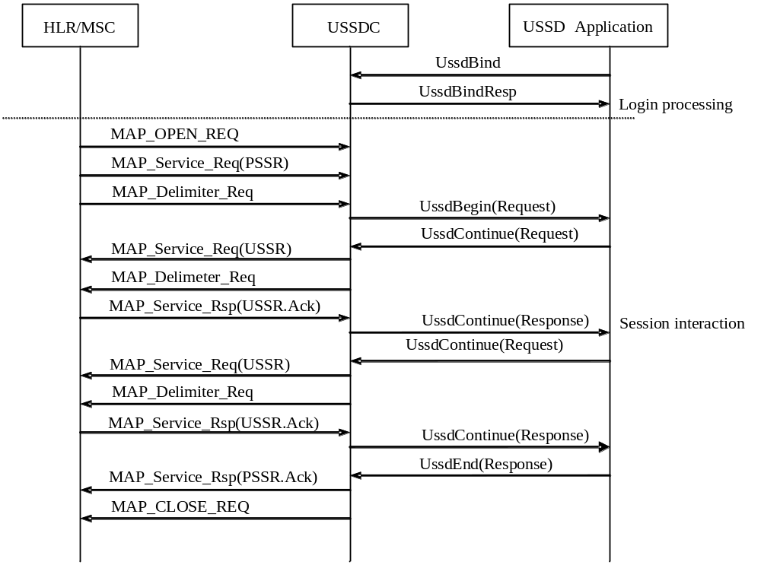
Figure 2 A USSD Session Initiated by a Mobile Station

A USSD Session Instance Initiated by the Service Party
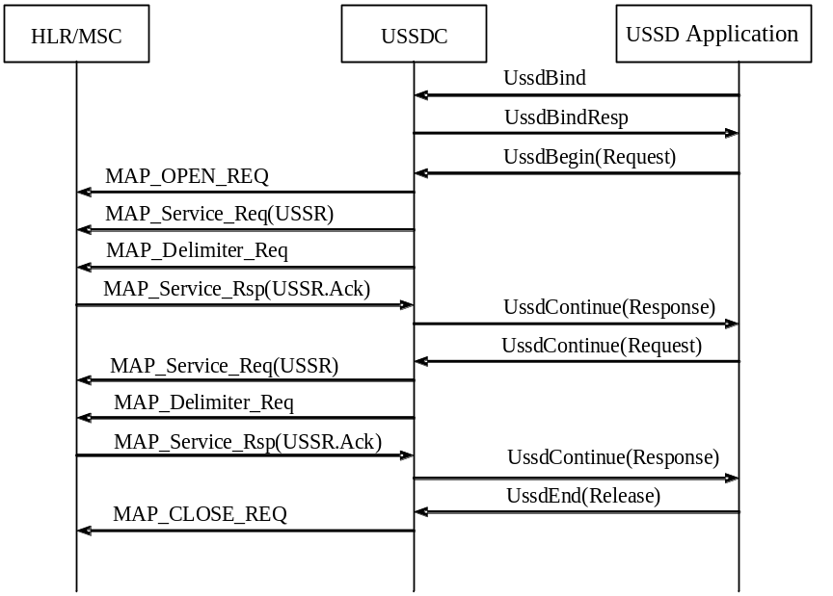
Figure 3 A USSD Session Initiated by the Service Party

